

Kilmore Primary School

STUDENT

ENGAGEMENT

POLICY

2018

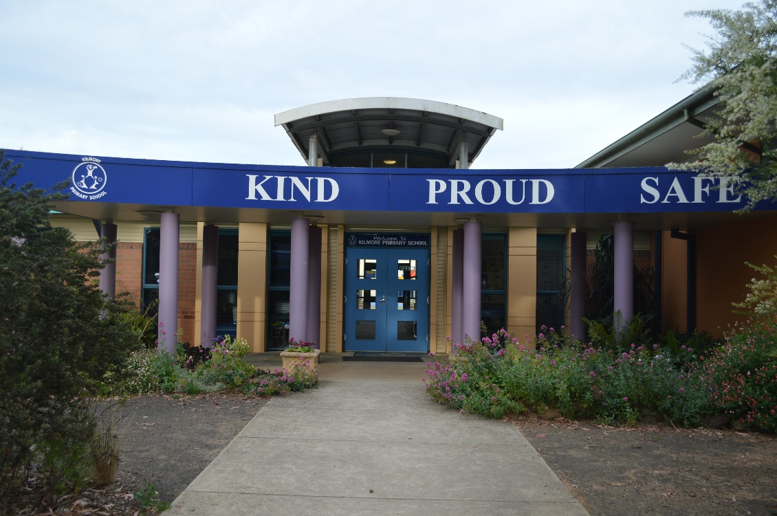



TABLE of CONTENTS

School Profile Statement . . . . . . . . . 3

Whole School Prevention Statement . . . . . . . 4

**Anti – Bullying** **. . . . . . . . . . 5**

School Improvement Strategies and Actions . . . . . 7

Rights and Responsibilities . . . . . . . . . 7

Parent Code of Conduct / Parent Rights & Responsibilities . . . 8

Staff Code of Conduct / Staff Rights & Responsibilities . . . 9

Student Code of Conduct / Student Rights & Responsibilities . . 10

Shared Expectations . . . . . . . . . . 11

Promoting School Attendance . . . . . . . . 12

Positive Behaviour Support Program . . . . . . . 13

School Actions & Consequences . . . . . . . 15

**APPENDIX ONE . . . . . . . . . . . 17**

**APPENDIX TWO . . . . . . . . . . . 18**

**APPENDIX THREE . . . . . . . . . . . 19**

**APPENDIX FOUR . . . . . . . . . . . 20**

**APPENDIX FIVE . . . . . . . . . . . 21**

School Profile Statement

Kilmore Primary School is located in Lancefield Road, Kilmore; an historic rural town 58km north of Melbourne. Kilmore is a semi-rural area comprising of small farm holdings, new housing estates and a well- established older town centre.

At present there are approximately 480 students enrolled at the school. A team of highly motivated, professional, and dedicated staff provide a safe and caring environment, where the goal is to optimise the learning outcomes and personal growth of all students. Kilmore Primary School aims to establish a happy, safe and supportive learning environment where the welfare of all children is a high priority and is maintained as a shared responsibility of the school and the community.

Our school provides an attractive, secure and stimulating educational environment. We have state of the art facilities with a strong emphasis on flexible learning spaces which are capable of supporting a wide variety of learning styles, programs and student needs. The school comprises spacious learning studios, an administration area, art room, library, hall, dedicated ICT centre, a sports stadium complex, utilised not only by the school but many community groups, a playground area for Foundation - Grade 2, an astro turf fitness circuit and a Grade 3-6 playground area. Out of School Hours care operates on the school site five days a week.

Policies and programs ensure a current and relevant curriculum, encompassing the Victorian Curriculum, professionally delivered with modern pedagogies in a high quality, whole school approach to teaching and learning. The Kilmore Primary School Way is a set of standards and practices that ensures each child is provided with the opportunity to achieve high academic standards, contribute to a culture that develops an appetite for learning and learn in an environment where they feel valued, safe and engaged in learning.

We are dedicated to ensuring that we meet the needs of the 21st century learner. We strive to provide a well-rounded education which values and supports the intellectual, creative, physical and emotional development of each child. We have a commitment to ensure that high expectations and quality learning and teaching are the central focus of our learning environments.

We offer Art, Physical Education, Digital and Design Technology and Spanish as specialist programs. A number of additional programs encourage student participation and offer opportunities for student leadership. Student Leadership Team, S.R.C, peer mediators, Life Education Van, lunchtime activities, Foundation - Grade 6 Buddies program, interschool sport, swimming program, school camps program, incursions and excursions are offered.

Our strong focus on student wellbeing is supported by our involvement in the Kids-Matter Mental Health Initiative and School Wide Positive Behaviours program. This approach enables us to provide early intervention strategies, and nurture happy, well balanced students. Keeping our children safe is an important responsibility we all share. Kilmore Primary School employs strategies to embed an organisational culture of child safety in compliance with the Child Safety Standards and Ministerial Order No. 870. Students, staff and families are further supported by the School Leadership Team, Wellbeing Coordinator, Teachers, DET Psychologist and Social Worker (SSSO), outside allied health professionals and specialists agencies.

A comprehensive positive behaviour support program complements our student wellbeing focus, and supports our school values: Kind, Proud and Safe. These values are further supported through the Ready, Set, Go program at the beginning of each school year, restorative justice practises, the Resilience Project and the KPS Manners Matter initiative.

Whole School Prevention Statement

Creating a positive School Culture

The creation of a positive school culture that is fair and respectful for all is vital for a school to be an effective learning environment. At Kilmore Primary School our aim is to establish a happy, safe and supportive learning environment where the welfare of all children is a high priority and is the shared responsibility of the school and the community. We strive to provide a quality education that will enable children to participate and contribute to the community. We want them to become informed lifelong learners and responsible citizens. We strive to foster a positive school environment free of bias and bullying where the students accept and respect the rights and responsibilities of all school community members. We encourage students to develop positive and caring relationships with others, a positive self-image and independence. We want them to be engaged in their learning, have a curiosity for learning, and to feel connected to the school so that they are keen to attend and to behave appropriately.

Our school values are:

*Kind* – we value all members of our community, encouraging and acting in a manner that is inclusive, caring and supportive.

*Proud* – we build self-esteem and social skills which enable children to develop academically and learn social and emotional skills which lead to a common sense of purpose, shared responsibility and mutual support.

*Safe* – each individual is treated with respect and trust and provided the opportunity to learn in a positive and supportive environment where they can reach their full potential.

At Kilmore Primary School we are dedicated to providing quality learning opportunities for all children. We strive to provide a well-rounded education which values and supports the intellectual, creative, physical and emotional development of each child. We have a commitment to ensure that quality learning and teaching are the central focus of our learning environments. Our school provides an attractive, secure and stimulating educational environment where our children are eager and excited to learn. We are implementing initiatives to increase student voice through Junior School Council and a dedicated professional learning team.

It is our belief that you are a critical part of your child's education at school. You are your child's first teacher and we encourage you to continue the next part of the learning journey with the school. There are many ways you can be involved as an active part of the Kilmore Primary School community, including attending and being part of School Council, joining our committed and talented Friends and Family group, helping out with the occasional working bee and assisting in many different ways in classrooms.

At Kilmore Primary School we proudly celebrate the learning of our students. We are dedicated to ensuring that we meet the needs of the 21st century learner and to providing a personalised learning environment for your child. In 2018 Kilmore Primary School will implement the DET Resilience & Respectful Relationships initiative.

Corporal punishment is prohibited at Kilmore Primary School.

**Anti - Bullying**

All members of the school community, parents, teachers and students will be aware of the school’s position on bullying. Bullying is repeated negative or harmful actions by a person or group towards a less empowered person or group that is intended to cause harm, fear or distress. Bullies are people who deliberately set out to intimidate, exclude, threaten and/or hurt others repeatedly. Bullying is a clear form of harassment. It may take many forms including:

* Physical bullying - includes fighting, pushing, shoving, punching, kicking, aggressive play fights or any unwanted touching that is used to harm, hurt or intimidate. It also includes any deliberate property damage.
* Verbal bullying – includes name calling, putting people down (both to their face and behind their back), intimidating noises and teasing people about their race, religion, appearance, family or friends.
* Visual bullying – offensive notes or electronic material either hand written or computer generated, damaging other people’s possessions, giving people looks and non-verbal signs which are used to intimidate them.
* Exclusion – deliberately leaving people out of activities or treating them as if they don’t exist, spreading rumours, deliberately making social invitations in front of them but not to them.
* Extortion- forcing someone to do something against their will by threatening violence against their person, property or reputation.
* Sexual bullying – touching or brushing past in a sexual manner, sexually oriented jokes, drawing or writing about someone’s body, unwanted advances of a sexual nature, using rude names and asking questions about someone’s personal life.
* Cyber bullying – Bullying that is carried out through an internet service, such as email, chat room, blog or instant messaging. It can also include bullying through mobile phone technologies such as short messaging service (SMS). Examples of cyber bullying include teasing, spreading rumours online, sending unwanted messages, or defamation. The sharing of digital images without permission.

Kilmore Primary School will adopt a four-phase approach to bullying.

**A Primary Prevention**

* Professional development for staff relating to bullying, harassment and proven counter measures.
* Community awareness and input relating to bullying, its characteristics and the school’s programs and response.
* Provide programs that promote resilience, life and social skills, assertiveness, conflict resolution and problem solving.
* Peer Mediators will be trained in December each year as yard leaders for the following year.
* School values and positive behaviour supports will be established and be embodied in daily practice, Strategies from programs such as The Resilience Project, Bullying No Way, and School Wide Positive Behaviours may be included.
* The curriculum to include anti-bullying messages and strategies eg: Bully Stoppers; Take a Stand, Lend a Hand and Bullying- No Way programs.
* Structured activities available to students at lunch breaks; Friendship club, Art room, Computer lab
* Buddy grades

**B. Early Intervention**

* Promote children and staff to report bullying incidents involving themselves or others.
* Classroom teachers and principal on a regular basis reminding students and staff to report incidents of bullying.
* Parents encouraged to contact school if they become aware of a problem.
* Public recognition and reward for positive behaviour and resolution of problems.
* If student bullying, including cyber bullying is evident or presented, parents will be contacted.

**C. Intervention**

* Once identified students involved (bully, victim and witnesses) will be spoken with, and all incidents or allegations of bullying will be fully investigated and documented.
* Students and staff identified by others as bullies will be informed of allegations.
* Students will be offered counselling and support.
* If student bullying, including cyber bullying persists parents will be contacted. If staff bullying persists the Principal will commence formal disciplinary action.

**D. Post Violation**

* Consequences implemented will be consistent with the school’s Behaviour Management Program.
* Consequences for ongoing behaviour will be individually based and may involve:
  + exclusion from class
  + exclusion from yard
  + school suspension
  + withdrawal of privileges
  + ongoing counselling from appropriate agency for students, if needed
* Reinforcement of positive behaviours – SWPB’s
* Classroom Meetings
* Support Structures
* Ongoing monitoring of students
* Rewards for positive behaviour
* Consequences for staff will be individually based and may involve:
  + counselling
  + a period of monitoring
  + a formal support group

|  |  |
| --- | --- |
| . **When things go wrong** | **When someone has been hurt** |
| * What happened? * What were you thinking at the time? * What have you thought about since? * Who has been affected by what you have done? In what way? * What do you think you need to do to make things right? | * What did you think when you realized what had happened? * What impact has this incident had on you and others? * What has been the hardest thing for you? * What do you think needs to happen to make things right? |

* + disciplinary actions

When working with students a teacher may use the following questions as a start to the conversation they have with children to resolve issues.

School Improvement Strategies and Actions

|  |  |
| --- | --- |
| Ready Set Go start-up program – two week program start of term one | Teach Like a Champion |
| Kilmore Way Instructional Model | High Expectations |
| Modelling by adults for attendance, work ethic, punctuality and behaviour | School attendance targeted with items in newsletter and on website |
| House Reward system – weekly and termly award | Parent involvement welcomed |
| Early intervention with “at risk” students | Special Celebration days |
| Anti-Bullying, Cyber Bully, Bullying No Way Day initiatives | Student Encouragement awards – Bee Tickets  Manners Matter |
| Welfare Program – counselling and student support | Young Leaders program – leadership skills training |
| Newsletter articles | Peer Mediation |
| Student representative council | Transition program |
| School and House captains | Inter School Sport |
| Buddies program | Student voice initiative |
| Restorative Practices – Class meetings | Foundation Discovery Days |

Rights and Responsibilities

All members of the School Community – students, teachers and parents have rights and certain responsibilities that must be recognized and accepted by members of the school community. A positive learning environment comes about when students, teachers and parents are involved in the learning process and have had their rights and responsibilities clearly defined.

Rights – ‘A Right is something to which you are entitled and cannot be taken away’

Responsibilities – ‘Responsibilities are the things that people should do without being told’

Kilmore Primary School provides a positive culture where bullying is not accepted. All stakeholders will have the right of respect from others, the right to learn or to teach, and a right to feel safe and secure in their school environment.

Our aims are:

* To reinforce within the school community what bullying is and is not, and the fact that it is unacceptable.
* Everyone within the school community to be alert to signs and evidence of bullying and to have a responsibility to report it to staff whether as observer or victim.
* To ensure that all reported incidents of bullying are followed up promptly and that support is given to both victims and perpetrators.
* To seek parental and peer-group support and co-operation at all times.

Parent Code of Conduct

Kind:

* listen to the views of others
* show consideration and courtesy to others
* respect the privacy and individual needs of others
* foster an attitude of mutual respect and cooperation

Proud:

* follow appropriate procedures when communicating with staff and others
* appropriately use and respect school facilities
* treat children, staff and others parents with integrity
* support school programs through participation, demonstrated interest in and encouragement of children’s work and progress
* keep informed of, and responsive to, school and classroom activities through newsletters and notices
* understand that individuals have different cultures, values, needs and interests and that children learn in different ways

Safe:

* reinforce the school values

Parent rights & responsibilities

Parents have a right to:

* expect that their child will be given access to a quality curriculum, stimulating and safe learning environment
* be kept informed about their child’s performance including academic, behaviour and attendance
* be informed when lateness and absences impact on positive student outcomes
* express themselves on school matters in appropriate forums
* have access to school personnel at mutually agreed times
* expect that their child will be safe at school and treated fairly
* confidentiality

Parents have a responsibility to:

* act in partnership with the school to promote their child’s learning and model and promote behaviour, aligned with school values - Kind, Proud, Safe
* support the education of their child, make every effort to be kept informed and be involved in the activities of the school where possible
* ensure their child attends school, is on time every day and provide the school with an explanation if the child is away
* respect all the staff of the school and value their expertise, ensuring that the time taken to speak with teachers does not take them away from teaching duties and classroom responsibilities
* encourage their child to understand and accept school rules and support agreed behavioural management decisions for their child
* To behave in an orderly, non abusive, non- threatening manner

Staff Code of Conduct

Kind:

* listen to the views of others
* respect the privacy and individual needs of others
* foster consideration, friendliness, patience and respect

Proud

* exhibit a professional manner & show respect when communicating with others
* appropriately use and respect school facilities and help maintain and improve the physical environment
* support decisions made by and for the school
* support & participate where possible in activities and events
* reinforce the school values
* demonstrate interest in and encouragement of children’s work, progress and celebrate and promote school community achievements
* display understanding and an acceptance of others
* understand that individuals learn in different ways and may have different values, needs and interests
* understand that different cultural groups can be represented in our class and community

Safe

* provide a welcoming and safe environment

Staff Rights and Responsibilities

* be valued and respected personally, professionally and treated fairly
* be supported by parents and carers of the students
* be shown courtesy and consideration by all in the school community & have their privacy respected
* work in a safe and supportive environment
* be provided with appropriate resourcing to teach a broad, balanced and differentiated curriculum
* professional development
* have personal and school property respected
* work in a clean, tidy and orderly environment
* expect student attendance & punctuality

Staff have a responsibility to:

* value and respect others in the school community
* ensure a professional approach
* keep parents informed about the curriculum and the progress of their children & provide opportunities for parental participation
* treat all in the school community with care, courtesy and consideration and offer support to colleagues, parents & wider community
* promote a safe and supportive environment for others - report OHS issues
* plan, evaluate and monitor their teaching and their student’s learning
* provide quality teaching & learning in line with the Victorian Curriculum
* maintain all resources
* undertake professional development in line with VIT requirements
* request professional development
* promote and maintain a clean, tidy and orderly environment
* inform parents and Leadership when lateness and absences impact on positive student outcomes
* adhere to school policy
* respect the privacy of others

Kind:

* listen carefully to others
* treat others with respect
* speak politely and respectfully
* demonstrate consideration for others & be willing to share and take turns
* work and play cooperatively
* be friendly, understanding and tolerant

Proud:

* wear the school uniform according to uniform policy
* look after your own property and things belonging to other people
* follow teachers’ instructions & work diligently and allow others to do the same
* acknowledge and accept the consequences of behaviour
* strive to be your best & act with integrity & speak truthfully
* allow others to work in a positive environment & take advantage of learning opportunities provided
* always try to resolve problems calmly, sensibly and fairly
* celebrate personal achievements and the achievement of others
* understand children learn in different ways and there are different ways of thinking and learning
* understand that individuals have different cultural backgrounds, values, needs and interests

**Safe:**

* practise behaviours that will help keep everyone healthy and safe
* understand and practise school rules and values
* practise behaviours that demonstrate care for the physical and natural school environment

Student Rights and Responsibilities

Students have a right to:

* feel safe and secure at school & be in an effective learning environment
* be treated in accordance to the school values
* have personal and school property respected
* be informed of rights, responsibilities & school expectations
* expect assistance with problem solving issues in a supportive environment at an appropriate time
* communicate, be heard & have opinions valued which are not offensive to others
* work & play in a safe clean environment & use and share equipment & facilities

Students have a responsibility to:

* attend school & help make our school a happy and safe place
* do their best and respect the rights of others to learn without disruption
* be punctual & meet work expectations
* treat others with respect in accordance to our school values
* accept individuality and cultural differences
* respect our school environment, including their own and others’ property
* apply rights, responsibilities & school expectations appropriately
* resolve conflict in a positive & cooperative manner, seek assistance if required
* actively listen, value others’ opinions, be honest & speak respectfully
* actively contribute to a clean & safe school environment

Student Code of Conduct

Shared Expectations

***Kind, Proud and Safe***

The KPS learning community has developed shared values and expectations to ensure that the learning, safety and rights of all are respected. The expectations are intended to be positive in that they set out what are expected and appropriate behaviours for our school. Our shared expectations are intended to support individual students and families who come to our community from a diversity of backgrounds, communities and experiences. This process is undertaken at the beginning of each year in our Ready, Set Go program. The expectations are intended to be positive and set out the appropriate behaviours for our school community. We have a responsibility to provide an educational environment that ensures all students are valued and cared for, feel they are part of the school, can engage effectively in their learning and experience success and strive for excellence.

Teachers build positive relationships by knowing the interests and backgrounds of each child and these are reflected in the learning program. Teachers value all students’ contributions. Teachers target questions in a way that acknowledges individual needs. Differences in thinking are embraced. A culture is encouraged where students take risks with their learning and it is acceptable for students to make an error. Teachers provide support and scaffolding where necessary. Students are encouraged to take responsibility for their learning. Opportunities are created for students to work in teams. Students are involved in decision making about their learning. Teaching strategies are used that engage students in learning – ideas are introduced with interesting and challenging activities, opportunities for discussion, group work and varied tasks that cater for multiple intelligences.

We make education accessible to all students by providing classroom support with teacher aides, visiting

teachers, intervention, integration for students with special needs and learning difficulties, speech pathology, student welfare and family support. Students and their families are supported by the staff and other professionals from DET school support services and/or private providers such as a psychologist, social worker, nurse and welfare officer.

Parents are encouraged to be involved through information sessions, parent morning teas, special event days/nights, school council, fundraising activities, special celebration days, assisting in the classroom and sports days. The local community is also involved via reciprocal visits with the local kindergartens & secondary colleges, swimming program, representation of KPS at ANZAC Day services and participation in the local show. Students visit Caladenia Nursing Home & Dianella Hostel for special events and visits to the school are conducted by the CFA and the Victorian Police Youth Officer for our area.

Students are encouraged to take greater responsibility for their learning as they progress through the school by being given extra responsibilities including running of house points, Young Leaders student leadership program conducting assembly, sports borrowing, junior school council, paper recycling, and office and lunch order assistants.

At information evenings and via newsletter articles parents are encouraged to have their child ready for school with a good night’s sleep, healthy breakfast, school uniform and reader, homework etc. Students are encouraged to attend regularly through awards including student encouragement awards and certificates and recognition for classes with good attendance. Parents are encouraged to send their children to school regularly and on time with as few absences as possible.

Promoting School Attendance

**Whole School Strategies**

The school will articulate high expectations to all members of the school community about attendance. They will adopt consistent procedures to record student absence and follow up student absences promptly. KPS will create a safe, supportive learning environment where all students experience success through active participation and engagement in purposeful learning. Notices will be placed in newsletters and on the website about absences and the resultant lost learning that happens when students are absent for extended periods of time. All staff members will be responsible for monitoring student absences with the student welfare officer taking primary responsibility. Individual Student Learning Plans that include punctuality and attendance as goals will be enacted for students who are chronically absent. A further more targeted response will be taken when absences are severe. Referral to community agencies for family support may also be needed.

**Shared Expectations for attendance**

Ensuring students attend each day is a shared expectation of parents, students and the school. Parents are required to make sure their child attends school at all times while the school is open for instruction. Parents are expected to provide educational support for their child and ensure that their child is on time each day. Parents are expected to notify school as soon as possible, preferably on the first day of the child absence or notify the school in advance if this is possible. Parents should support their child’s learning during any prolonged absence by organising a discussion with the class teacher prior to the absence. Parents are expected to work co-operatively with the school if attendance has been inconsistent and unsatisfactory. Students are expected to attend school, to arrive on time and to every class, whenever the school is open for instruction. Students are expected to provide a written explanation from their parent when they have been absent from school. Students should remain on the school premises unless they have permission to leave from both the school and their parents.

**Recording and monitoring attendance**

School should ensure the attendance is recorded twice a day on Sentral and pursue and record an explanation for every absence, as in CASES21.

*See Kilmore Primary School Attendance Policy*

**Attendance follow-up**

Three consecutive unexplained absences are followed up with a phone call. If no satisfactory response within 5 school days then an email/letter is sent home. When a student’s attendance pattern is of concern to the school an informal or formal meeting will be convened with the parents to discuss attendance and the support needed for the student/family to resolve the attendance issue. Parents and the school will work together in an effort to improve the attendance of the student. The state-wide campaign of ‘It’s not OK to be away’ will continue to be pursued at our school in line with DET expectations

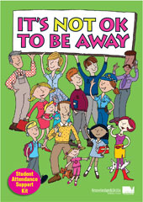

Positive Behaviour Support Program

### At Kilmore Primary School we aim to have a kind, proud and safe learning environment inside and outside the classroom where all members of the school community can:

* Interact in a friendly, positive way
* Feel welcome and safe
* Be recognised for the positive contribution they can make to the school

The program is based on the following beliefs:

* The values of our school will be clearly stated and regularly reinforced
* Positive reinforcement (bee tickets) and the development of intrinsic motivation will be an integral part of the program
* All people involved in the program need to be fully informed of the aims and details of the program
* The program needs to be fairly, reasonably and consistently applied
* Development of positive self- esteem is of utmost importance

**Promoting Positive Behaviour**

Children who contribute positively to our learning community through their behaviour and the manner in which they treat others will be formally recognised or rewarded.

This may include:

* Praise, reinforcement, acknowledgment of behaviour
* Regular student recognition
* Positive phone calls/communication to home
* 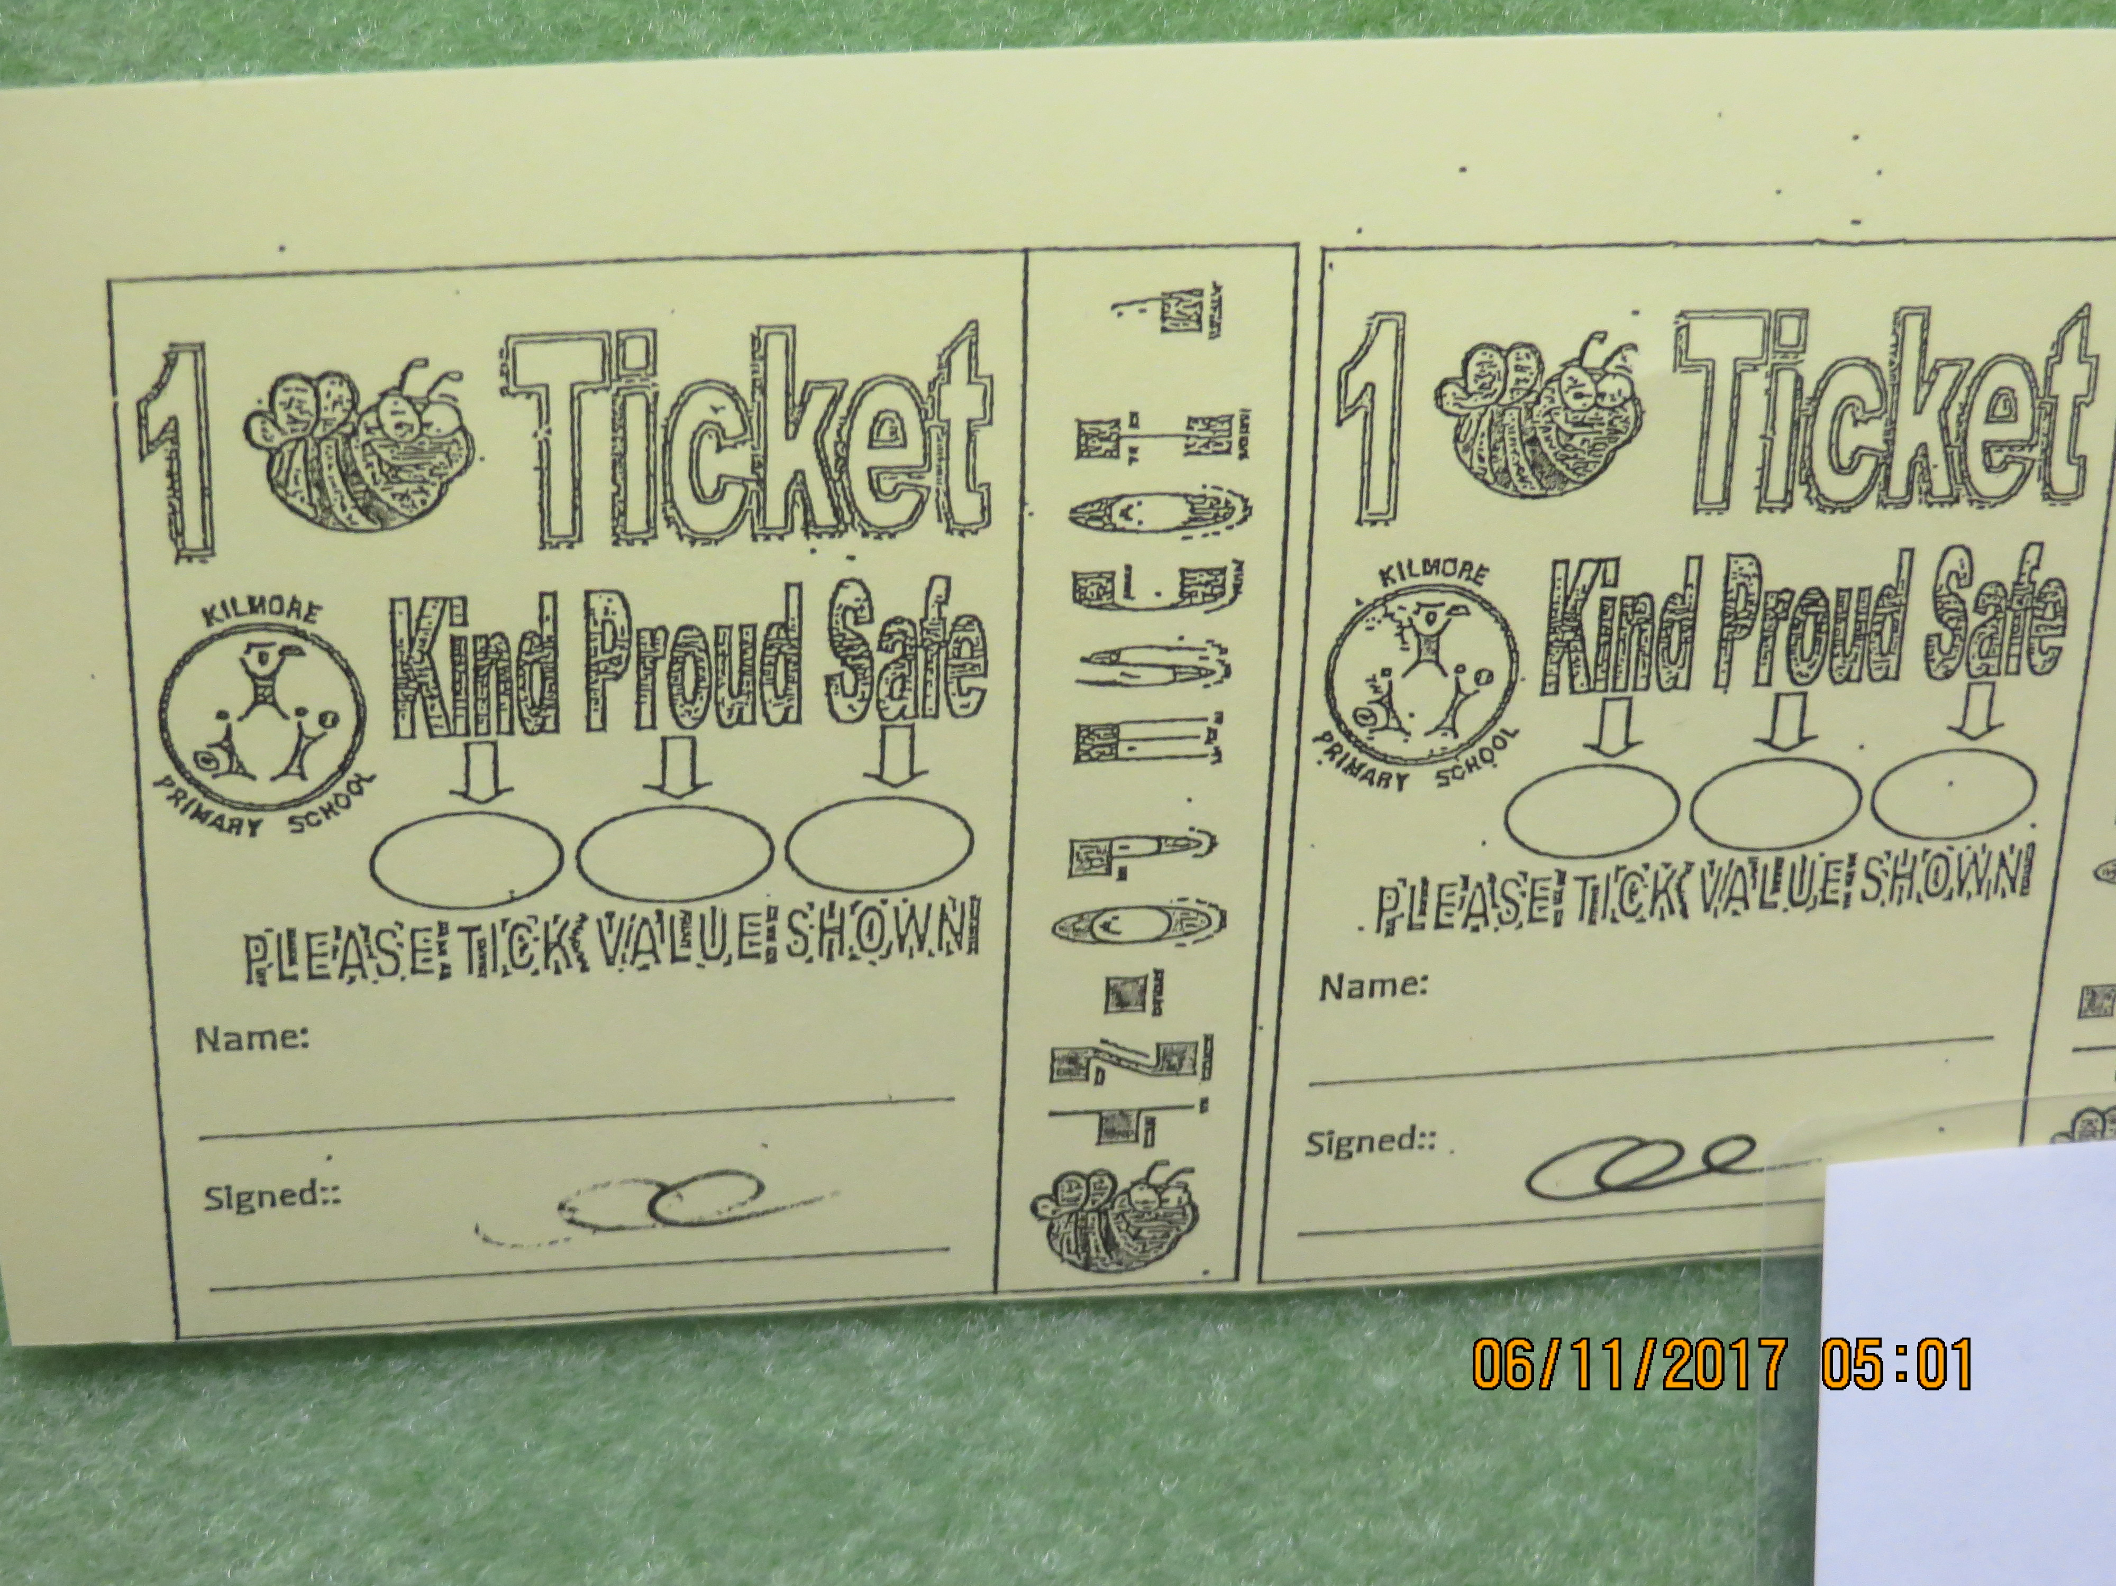Recognition in school newsletter

Bee tickets, which lead to:

* Special responsibilities
* Stickers, certificates etc
* Special activity
* Negotiated rewards

Children may receive a ‘Bee Ticket’ for demonstrating our school values by being kind, proud and safe in the school grounds or the classroom.

* One Bee Ticket = 1 House Point as well as individual recognition
* Children may also receive house points for positive behaviour, which contributes to an overall score

*See KPS Positive Behaviour Support chart below*

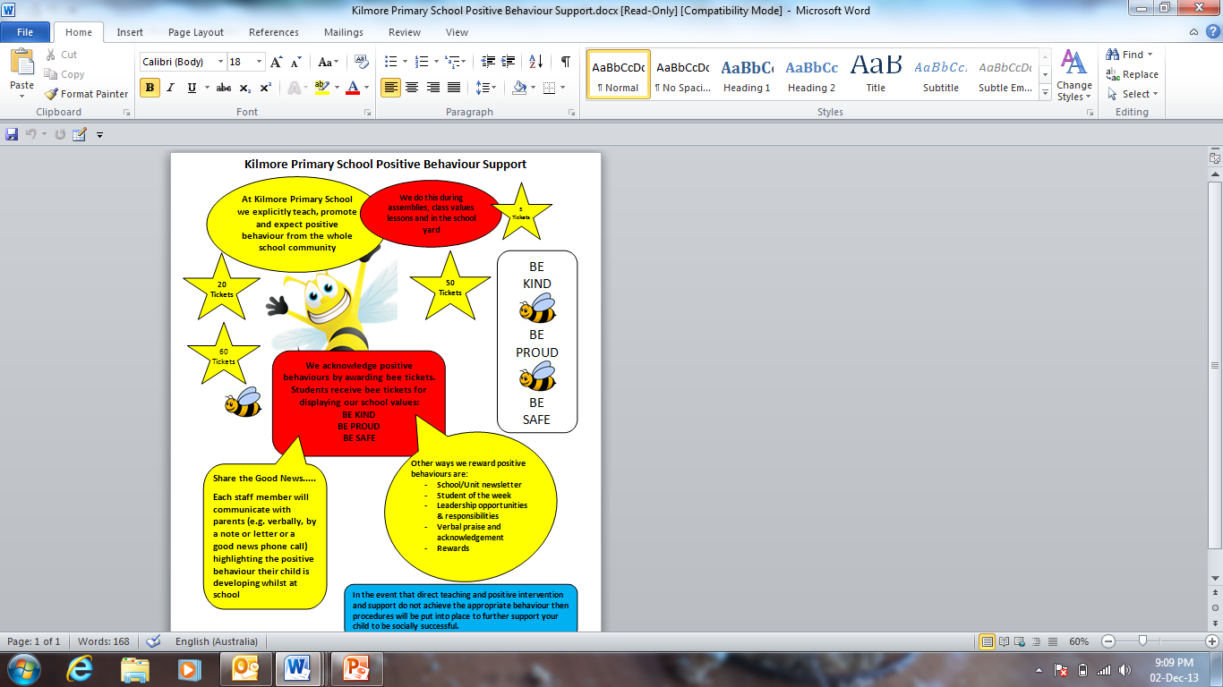

School Actions and Consequences

The Code of Conduct for all stakeholders at Kilmore Primary School has been formulated within and is consistent with the DET student engagement guidelines. We recognise that our school must provide all children with a safe and orderly learning environment that meets the needs of our children from Foundation to Grade 6. Student behaviour that is not consistent with the school values will be addressed by the principal class in line with the DET guidelines.

At the beginning of each school year and each term, and as appropriate, teachers will work with their students to review values and behaviours.

The goal of a Student Engagement policy is to encourage students to accept responsibility for their actions and to participate fully and positively in their educational experience. DET discipline procedures should only be used when all other options have been exhausted or where the wellbeing or safety of a student or staff member is at risk.

*See KPS Student Welfare Policy, KPS Bullying & Harassment Policy& KPS Child Safety Policy.*

*Inappropriate Behaviour – Classroom*

During the first two weeks of the school year, each grade participates in the Ready, Set, Go program focusing on the school values and classroom rules and expectations which is developed and published as a guide to expectations. As well as this, behavioural management strategies in the classroom are administered within the framework of our classroom behaviours management process - a model developed by staff and influenced by the positive behaviour system *– (see chart below).* Our staff aims to encourage, establish, reward and restore positive behaviour, all within the framework of our School values – Kind, Proud and Safe. Inappropriate behaviours such as disrespect and repeated classroom disruption are directed to the School Leadership Group who supervise time in during a recess or lunchtime.

*Inappropriate Behaviour - Yard*

In the yard, children who behave outside the agreed values may be managed in one of four ways, depending on the level of misbehaviour. Minor matters such as friendship issues or isolation are directed to peer mediators to assist with, whilst children can take concerns of a slightly greater nature to teachers in the yard. These may include issues with lining up, sandpit issues, unfair decisions in games etc. Behaviours of a more concerning nature such as disrespect, pushing and shoving are directed to the school leadership group who supervise time out and finally the most severe issues including violent behaviour, swearing, etc. are directed to the Principal where a letter of Inappropriate Behaviour or Letter of Inappropriate Language may be issued. *(See Yard Discipline Procedures chart below)*

At each of these stages, all concerned are encouraged to reflect on behaviour by filling in a reflection notice which are sent home to parents. This is to help children identify what happened, who was affected and how it can be fixed. Every discussion is accompanied with strategies to help children move forward from the situation.

A time in/out automatically attracts a detention for ½ of either recess or lunchtime. During this time, children are asked to reflect on their actions by filling out a reflection notice. Teachers are required to record incidents of inappropriate class and yard behaviours on the Sentral database. This will enable the school to track individual behaviour and the types of incidents occurring, and be proactive in developing strategies to modify behaviour. All children will have a fresh start at the beginning of a new term.

*DET Guidelines: Procedures for Suspension/Expulsion*

Before suspension or expulsion, the most serious consequences can be given, there is a clear procedure to be followed. A Targeted Intervention should be tried and this is appropriate when a student is displaying a chronic pattern of problem behaviour or the safety or wellbeing of a person is infringed in a serious manner.

The targeted Intervention should adhere to the following criteria:

*collection of data about the behaviour and analysis of that data

*teaching of pro-social replacement behaviours

*progress measured and support reduced slowly.

*intervention in the classroom first and involving the class teacher

*academic and social problems addressed

*parental involvement

*Student Support Group established comprising Principal or delegate, parents, class teacher, student if appropriate and any professional involved eg. Welfare Officer, Social Worker.

Students should only be excluded from school when all other measure have been implemented without success or where an immediate suspension is the only appropriate course of action given the students serious behaviour. It should be for the shortest time possible and In-School rather than Out of School should be the preferred option.

*This policy will be reviewed as part of the policy review cycle.*

*This policy was last ratified by School Council in December 2017.*

*APPENDIX 1 - KPS Behaviour Matrix*

*APPENDIX 2 – KPS Classroom Behaviour Management Process*

*APPENDIX 3 – KPS Yard Behaviour management process*

*APPENDIX 4 - DET guidelines – Suspension policy*

*APPENDIX 5 – DET guidelines - Expulsion policy*

APPENDIX 1

|  |  |  |  |
| --- | --- | --- | --- |
| **Area** | **Kilmore Primary School Behaviour Matrix** | | |
| **Be Kind** | **Be Proud** | **Be Safe** |

|  |  |  |  |
| --- | --- | --- | --- |
| **All Learning Areas**  [http://t3.gstatic.com/images?q=tbn:ANd9GcSeUcBSFqEgd17X8AoXMI2SX5ZZcwYcrdwJZis-GGUy24L7pAHo](http://www.google.com.au/imgres?q=learning+area&hl=en&safe=active&biw=1249&bih=588&tbs=itp:clipart&tbm=isch&tbnid=-iCTHUWVG9M2eM:&imgrefurl=http://www.boddingtondhs.wa.edu.au/BDHS_Learning_Area_kindy.html&docid=zAwgbZPcqSHXnM&imgurl=http://www.boddingtondhs.wa.edu.au/Site/images/BDHS_Learning_Area_kindy_clip_image002_0000.gif&w=543&h=310&ei=3Ep6UIbFFY2kiAfHxYGgCQ&zoom=1&iact=hc&vpx=121&vpy=201&dur=117&hovh=170&hovw=297&tx=121&ty=81&sig=114886506937087999884&page=1&tbnh=150&tbnw=262&start=0&ndsp=17&ved=1t:429,r:0,s:0,i:73) | * **I follow directions** * **I look after equipment** * **I take turns and use my manners** * **I listen carefully** * **I respect others** * **I use a friendly voice** * **I use appropriate words** | * **I am prepared and stay organised** * **I manage my time** * **I do my best** * **I ask questions to help my learning** | * **I walk** * **I sit on my chair** * **I push my chair in** * **I use the bag areas** * **I clean up** * **I use equipment safely** * **I keep my hands and feet to myself** |
| **Inside/Outside Play areas**  [http://t2.gstatic.com/images?q=tbn:ANd9GcSm5EHKegRZ-X21RKzLrWeYyfScOMfRYxKEgrNGpR27PCacQXyw](http://www.google.com.au/imgres?q=play+ground&hl=en&safe=active&biw=1249&bih=588&tbs=itp:clipart&tbm=isch&tbnid=Bt7mI7xTyriXFM:&imgrefurl=http://www.getinvolved.ca/2012/05/giver/&docid=PTUVfStz-M369M&imgurl=http://www.getinvolved.ca/wp-content/uploads/2012/05/playgroundaag.gif&w=451&h=317&ei=Fkt6UJmrJujpiAew54Eo&zoom=1&iact=hc&vpx=503&vpy=288&dur=38&hovh=188&hovw=268&tx=147&ty=112&sig=114886506937087999884&page=2&tbnh=135&tbnw=192&start=13&ndsp=25&ved=1t:429,r:15,s:0,i:120) | * **I invite others to play** * **I play ball games on the oval or basketball courts** * **I return equipment** * **I respect others** * **I share and take turns** * **I use a friendly voice** * **I use appropriate words** | * **I put my rubbish in the bin** * **I wear my hat** * **I wear my uniform correctly** * **I respect the school grounds** | * **I wear my hat** * **I play in the correct areas** * **I wear appropriate footwear** * **I keep my hands and feet to myself** |
| **Eating Area**  [http://t1.gstatic.com/images?q=tbn:ANd9GcQ6qWjnvOe32imiMt26BP_oanUf607ppBkU96wiL1-r4zp7-HPjJA](http://www.google.com.au/imgres?q=students+eating+lunch&hl=en&safe=active&biw=1249&bih=588&tbs=itp:clipart&tbm=isch&tbnid=F1L5Z4nsnSL7-M:&imgrefurl=http://www.lmsed.org/lhs%20web%20site/home%20page/default.html&docid=efT5EdxN7-eyTM&imgurl=http://www.lmsed.org/lhs%20web%20site/cafeteria.jpg&w=1987&h=1391&ei=Skx6UP_bAaLtiAfJ44HoDA&zoom=1&iact=hc&vpx=199&vpy=277&dur=143&hovh=188&hovw=268&tx=135&ty=118&sig=114886506937087999884&page=2&tbnh=145&tbnw=207&start=13&ndsp=26&ved=1t:429,r:13,s:20,i:178) | * **I listen to the person on duty** * **I use my manners** * **I share the eating area with others** | * **I put my rubbish in the bin** * **I clean up any mess I make** | * **I eat my own food** * **I walk in the eating area** * **I sit on seats** * **I stay in the eating area until finished** |
| **Transition and**  **Student Movement** | * **I move quietly around the school** | * **I line up when I hear the music** * **I stay in my line** | * **I keep to the left** * **I keep my hands and feet to myself** * **I walk** |
| **Toilets & Taps**  [http://t2.gstatic.com/images?q=tbn:ANd9GcQ0Vr4dTuzLqV0jIxDmqS-4WB7i9nfR2K_T16BE2xqQlkOdmf6g](http://www.google.com.au/imgres?q=toilets&hl=en&safe=active&biw=1249&bih=588&tbs=itp:clipart&tbm=isch&tbnid=_MxyoKKyRk5rkM:&imgrefurl=http://www.teacherfiles.com/clip_art_symbols_signs.htm&docid=9v3kwoMI9W9lWM&imgurl=http://www.teacherfiles.com/clipart/xsigns/clip_art_toilets_2.gif&w=400&h=401&ei=Gkx6UKVwsJqIB9nTgJAI&zoom=1&iact=hc&vpx=637&vpy=249&dur=114&hovh=225&hovw=224&tx=64&ty=204&sig=114886506937087999884&page=1&tbnh=138&tbnw=137&start=0&ndsp=22&ved=1t:429,r:11,s:0,i:106) | * **I keep the area clean and tidy** * **I am water wise** * **I understand people’s privacy** * **I responsibly use the toilets** | * **I am water wise** * **I keep the area clean and tidy** * **I look after school property** | * **I know how germs are spread** * **I am water wise** * **I responsibly use the toilets** * **I walk** |
| **Out of School Entry/Exit**  C:\Program Files\Microsoft Office\MEDIA\CAGCAT10\j0183328.wmf | * **I am friendly** * **I respect the bus driver and the rules** * **I only touch my property in the bike shed** * **I listen to the crossing ladies’ instructions** | * **I represent the school appropriately** * **I put my rubbish in the bin as I exit** | * **I know and follow the road rules** * **I walk my bike or scooter through the school yard** * **I report inappropriate behaviour** * **I walk on the left of the footpath** |
| **“Dealing with Kilmore Primary School staff” Office/Staffroom** | * **I am polite and helpful** * **I wait quietly for my turn** | * **I am polite and respectful** | * **I am polite and careful** |
| **Using Digital Technologies** | * **I respect others equipment** * **I am the only one who uses my personal device** * **I interact respectfully with others** * **I only take photos/videos for work purposes which remain on my device or are later deleted** | * **I only use my device for work purposes and when instructed** * **I use my device to create quality pieces of work** * **I put my work into my own words** | * **I charge my device at home** * **I stay in one spot to use my device and put it away when it is not being used** * **I practise netiquette and cyber safety rules when using my device** * **I only use my device where a teacher can see my screen** |

APPENDIX 2

**Kilmore Primary School Classroom Behaviour Management Process**

**Observe Behaviour**

– determine whether the behaviour is major or minor

Teacher ensures the safety of all students

Teacher initiates the School Behaviour Management Plan

**Minor Behaviours/Major Behaviours**

**(dealt with by) (dealt with together**

**the teacher) with leadership)**

Student sent to the office or call for leadership assistance if needed

1st Incident- Verbal warning is given and behaviour recorded

In case of extreme/urgent assistance, make 555 announcement requesting leadership to your area

2nd Incident- Student is directed to move to another location in the classroom and behaviour is recorded

**Minor Behaviours**

- Late to class

- Unprepared (no materials)

- Violation of classroom expectations

- Low level disrespect

- Classroom disruption

- Unsafe behaviour

- Cheating

- Minor theft

- Minor vandalism (drawing on table etc)

3rd Incident- Student directed to another classroom for approx 5 mins. Behaviour is recorded on Sentral (Refusal to leave is a Major behaviour- refer child to leadership)

Teacher completes record of incident on Sentral

Leadership discusses behaviour with student

Consequence to be determined by leadership (in consultation with teacher)

Classroom Teacher records Time-in on Sentral. Student attends a Time-In. Attendance recorded on Sentral.

**Major Behaviours**

- Repeated minor behaviour

- High level disrespect

- Abusive/inappropriate language

- Harassment/imtimidation

- Fighting/physical aggression

- Harming self or others

- Major vandalism

-Theft

- Truanting

- Drug or substance abuse

- Leaving the room without permission

Follow-up discussion between student/teacher and/or leadership before student returns to the classroom

Follow through with consequences, parents notified

When the student has 3 minor incident /Time-ins in a week leadership is informed. A phone call is made to parents.

APPENDIX 3

**Kilmore Primary School Yard Behaviour Process**

**Observe Behaviour**

– determine whether the behaviour is major or minor

Decide how the problem can be solved

-Discussion with student/s

-Bounceback strategies

-Restorative justice processes

-Peer Mediators

Ensure the safety of all students

**Minor Behaviours Major Behaviours**

**(dealt with by (dealt with together**

**teacher or peer with Leadership)**

**Mediators)**

**medators)**

Send student to the office or call for leadership if assistance is neeeded

**Minor Behaviours**

-Late for Line up

-Not wearing correct uniform (eg. no hat)

-Misuse of outdoor furniture & equipment

-Excluding others

-Unkind behaviour towards others

-Taking other people’s property

-Rough play (eg. play fighting/tackling)

-Incidental swearing

-Littering

-Being in the wrong area (eg. on the wrong year level playground)

-Out of bounds (eg. over the red line)

-Damaging trees or plants

-Throwing inappropriate objects

In case of extreme/urgent assistance, make 555 announcement requesting leadership to your area

**Determine consequences**

-walk with yard duty teacher

-removed from area

-restricted to an area

-separate students

-time out for 5mins in yard area supervised by Teacher

-rubbish duty

-confiscate object/s

-suggest an alternative activity

Teacher completes record of incident on Sentral

Talk to student about behaviour

|  |  |
| --- | --- |
|  |  |

Consequence to be determined by leadership (in consultation with teacher)

TEACHER CAN HELP

Follow through with consequences

Follow through with consequences

**Major Behaviours**

-Disrespecting others property

-Leaving the school grounds

-Threatening others with an object

-Deliberately trying to hurt someone

-Throwing things in a dangerous manner

-Defiance

-Swearing at anyone

-Bullying in any form

-Displaying ‘gang-like’ behaviour

-Theft

-Vandalism

Document behaviour and consequence on Sentral

Sentral updated to reflect consequences and actions taken.

Follow-Up discussion between student/teacher and/or leadership before student returns to the yard

APPENDIX 4

DET Procedures for Suspension

What has to happen before a suspension occurs?

In order to suspend a student a principal must ensure that a range of strategies have been implemented to meet the educational, social and emotional needs of your child and that these strategies have not helped your child demonstrate more positive behaviour.

A student support group is then set up to explain to you and your child that a suspension is being considered. All participants in the meeting should try and to begin a process of effective communication and identify issues that are of concern to you, your child or the school. The student support group then develops a range of strategies to support you and your child in addressing these areas of concern.

Reasons for suspension

Students can be suspended if, while at school, travelling to or from school or during an out-of-school activity (including travel there and back), they:

(a) threaten or constitute a danger to the health, safety or wellbeing of any person

(b) commit an act of significant violence against a person or cause significant damage to or destruction of property; are knowingly

involved in the theft of property

(c) possess, use, or deliberately assist another person to use prohibited drugs or substances

(d) fail to comply with any reasonable and clearly communicated instruction of a principal, teacher or other staff member

(e) consistently interfere with the wellbeing, safety or educational opportunities of any other student

(f) consistently vilify, defame, degrade or humiliate another person based on age; breastfeeding; gender identity; impairment; industrial activity; lawful sexual activity; marital status; parental status or status as a carer; physical features; political belief or activity; pregnancy; race; religious belief or activity; sexual orientation; personal association (whether as a relative or otherwise) with a person who is identified by reference to any of the above attributes.

How long is a suspension for?

The maximum suspension is five school days in a row and no more than 15 school days a year, unless permission is granted by the Department of Education and Early Childhood Development’s regional director for a longer period of suspension. Suspensions cannot continue over the school holiday period into the following term.

Procedures for suspension

When a principal decides on suspension, a student support group meeting is set up to:

• explain to you and your child why, when and where the suspension will happen (e.g. in-school or out of school)

• provide contact details for additional support services

• develop, in conjunction with you, your child (if appropriate) and your child’s teacher/year level coordinator, a Student Absence Learning Plan outlining school work to be done during the suspension. If your child is suspended, the school must provide you and your child with a Notice of Suspension and a copy of this brochure before the suspension begins. If the suspension is for five consecutive days, the principal must also provide you with details of the post-suspension student support group meeting.

Immediate suspension

A student can be suspended immediately if their behaviour warrants ordinary suspension or if they are putting the health, safety and wellbeing of themselves, staff or other students at significant risk. In the case of immediate suspension you will be told without delay and a student support group will be held within 48 hours to ensure appropriate support for your child is in place. The school must provide you and your child with a Notice of Suspension and a copy of this brochure at the student support group.

Post-suspension student support group

If the suspension is for five consecutive days you and your child must attend a post-suspension student support group on the day your child returns to school to:

• review the Student Absence Learning Plan and the school work completed during suspension

• develop a Return to School Plan

• develop strategies within and outside of the school to meet your child’s educational, social and emotional needs

• discuss the ongoing responsibilities of you, your child, the school and any other professional at the meeting.

Suspension complaint process

It is best to raise any concerns you have about your child’s suspension at the start of the student support group meeting. If, at the end of this meeting, you feel your complaint has not been adequately addressed then you should speak to the school principal.

The Department of Education and Early Childhood Development website provides additional information, phone numbers and further contact details for parent complaints. Go to [**http://www.education.vic.gov.au/about/contact/parentcomplaint.htm**](http://www.education.vic.gov.au/about/contact/parentcomplaint.htm)

APPENDIX 5

Procedures for Expulsion

What has to happen before expulsion?

In order to expel a student, a principal must ensure that a range of strategies have been implemented to meet the educational, social and emotional needs of your child and that these strategies have not helped your child demonstrate more positive behaviour.

A student support group is then set up to explain to you and your child that an expulsion is being considered. All participants in the meeting should try and to begin a process of effective communication and identify issues that are of concern to you, your child or the school.

When can expulsion occur?

Students can be expelled if, while at school, travelling to or from school or during an out-of-school activity (including travel there and back), they:

(a) threaten or constitute a danger to the health, safety or wellbeing of any person

(b) commit an act of significant violence against a person or cause significant damage to or destruction of property; are knowingly

involved in the theft of property

(c) possess, use, or deliberately assist another person to use prohibited drugs or substances

(d) fail to comply with any reasonable and clearly communicated instruction of a principal, teacher or other staff member

(e) consistently interfere with the wellbeing, safety or educational opportunities of any other student

(f) consistently vilify, defame, degrade or humiliate another person based on age; breastfeeding; gender identity; impairment; industrial activity; lawful sexual activity; marital status; parental status or status as a carer; physical features; political belief or activity; pregnancy; race; religious belief or activity; sexual orientation; personal association (whether as a relative or otherwise) with a person who is identified by reference to any of the above attributes. AND The student’s behaviour is of such magnitude that it is the only option left after balancing the need for the student’s continued education against the health, safety and wellbeing of other students and staff.

Expulsion procedures

Prior to expulsion, a student support group is convened to discuss the expulsion and allow you and your child an opportunity to be heard. At this meeting a Notice of Expulsion is given to you and your child, along with this brochure and a copy of the Expulsion Appeal proforma. The Department of Education and Early Childhood Development’s regional director (or nominee) will also attend the student support group. For students in Out of Home Care, the principal must ensure the meeting is attended by the DHS case manager and the student’s primary carer or person the student normally lives with.

Pathways and transitions

The student support group must identify your child’s most suitable future educational, training and/or employment options and work

together to ensure that there are good transition arrangements in place. Following the student support group, if the principal determines that enrolment at another school or a registered training organisation is the best option for your child then the whole student support group must work towards this.

What happens after an expulsion?

The principal and regional director (or nominee) are responsible for making sure that your child is enrolled in another school or registered training organisation or that an appropriate employment opportunity is identified. The principal and the regional director (or nominee) must then schedule a meeting with any new school or registered training organisation, and ensure all information relevant to your child is forwarded in accordance with the *Information Privacy Act 2000.* If you would like to appeal your child’s expulsion, you must do so within 10 school days from the start of the expulsion.